Acharya Institute of Technology

Acharya Dr. S. Radhakrishnan Road, Acharya P.O Soladevanahalli, Bangalore - 560107, Karnataka, India
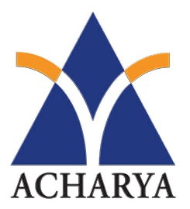

DEPARTMENT OF ARTIFICIAL INTELLIGENCE & MACHINE LEARNING

MONGODB
BDSL456B
Laboratory Internal Assessment Test - 1 Academic Year- 2025-2026 (Even Semester)

Name | :________________________________________________________________
USN | :________________________________________________________________
Sem and Section | :________________________________________________________________
Subject | :________________________________________________________________

Test No | Date | Max Marks | Marks  Obtained | Sign of Staff  member | Signature of  student
1

Write Up (20) | Conduction (20) | Result (10) | Procedure (10) | Viva Voce (40) | Total (100)

Sign of Staff In charge Head of the department

